
GREATER NOIDA INSTITUTE OF TECHNOLOGY
GREATER NOIDA
B. TECH FIRST YEAR, EVEN SEMESTER, 2022-2023

PROGRAMMING FOR PROBLEM SOLVING LAB
(BCS-251)



Submitted to: Horesh Kumar | Submitted by:
Assistant Professor | Section:
Department of CSE | University Rollno:

PROGRAMMING FOR PROBLEM SOLVING LAB (BCS-251)
INDEX
 | SNO. | PROGRAM | DATE | SIGN
LAB 1 | 1. | Write a program that accepts the marks of 5 subjects and finds the sum and percentage of marks obtained by the student.
LAB 1 | 2. | Write a program that calculates the Simple Interest and Compound Interest. The Principal Amount, Rate of Interest, and Time are entered through the keyboard.
LAB 1 | 3. | Write a program to calculate the area and circumference of a circle.
LAB 1 | 4. | Write a program that accepts the temperature in Centigrade and converts it into Fahrenheit using the formula C / 5 = (F – 32) / 9.
LAB 1 | 5. | Write a program that swaps the values of two variables using a third variable.
LAB 2 | 6. | Write a program that checks whether the two numbers entered by the user are equal or not.
LAB 2 | 7. | Write a program to find the greatest of three numbers.
LAB 2 | 8. | Write a program that finds whether a given number is even or odd.
LAB 2 | 9. | Write a program that tells whether a given year is a leap year or not.
LAB 2 | 10. | Write a program that accepts marks of five subjects and finds percentage and prints grades according to the following criteria:
  Between
  90-100%—————————Print ‘A’
  80-90%—————————–Print ‘B’
  60-80%—————————–Print ‘C’
  Below 60%————————Print ‘D’.
LAB 3 | 11. | Write a program that takes two operands and one operator from the user and performs the operation and prints the result by using the Switch statement.
LAB 4 | 12. | Write a program to print the sum of all numbers up to a given number.
LAB 4 | 13. | Write a program to find the factorial of a given number.
LAB 4 | 14. | Write a program to print the sum of even and odd numbers from 1 to N numbers.
LAB 4 | 15. | Write a program to print the Fibonacci series.
LAB 4 | 16. | Write a program to check whether the entered number is prime or not.
LAB 5 | 17. | Write a program to find the sum of digits of the entered number.
LAB 5 | 18. | Write a program to find the reverse of a number.
LAB 5 | 19. | Write a program to print Armstrong numbers from 1 to 1000.
LAB 5 | 20. | Write a program to convert the binary number into a decimal number and vice versa.
LAB 6 | 21. | Write a program that simply takes elements of the array from the user and finds the sum of these elements.
LAB 6 | 22. | Write a program that inputs two arrays and saves the sum of corresponding elements of these arrays in a third array and prints them.
LAB 6 | 23. | Write a program to find the minimum and maximum elements of the array.
LAB 6 | 24. | Write a program to search an element in an array using Linear Search.
LAB 6 | 25. | Write a program to sort the elements of the array in ascending order using the Bubble Sort technique.
LAB 7 | 26. | Write a program to add and multiply two matrices.
LAB 7 | 27. | Write a program that finds the sum of diagonal elements of a m x n matrix.
LAB 8 | 28. | Write a program to implement strlen ( ), strcat ( ), strcpy ( ) using the concept of Functions.
LAB 9 | 29. | Define a structure data type TRAIN_INFO. The type contains Train No.: integer type, Train name: string, Departure Time: aggregate type TIME, Arrival Time: aggregate type TIME, Start station: string, End station: string. The structure type TIME contains two integer members: hour and minute. Maintain a train timetable and implement the following operations:  (i) List all the trains (sorted according to train number) that depart from a particular station.  (ii) List all the trains that depart from a particular station at a particular time.  (iii) List all the trains that depart from a particular station within the next one hour of a given time.  (iv) List all the trains between a pair of start station and end station.
LAB 10 | 30. | Write a program to swap two elements using the concept of pointers.
LAB 10 | 31. | Write a program to compare the contents of two files and determine whether they are the same or not.
LAB 10 | 32. | Write a program to check whether a given word exists in a file or not. If yes then find the number of times it occurs.

LAB 1
1. WAP that accepts the marks of 5 subjects and finds the sum and percentage marks obtained by the student.
#include <stdio.h>
#include<conio.h>
void main()
{
float eng, phy, chem, math, comp;
float total, average, percentage;
printf("Enter marks of five subjects: \n");
scanf("%f%f%f%f%f", &eng, &phy, &chem, &math, &comp);
total = eng + phy + chem + math + comp;
average = total / 5.0;
percentage = (total / 500.0) * 100;

printf("Total marks = %f\n", total);
printf("Average marks = %f\n", average);
printf("Percentage = %f", percentage);
getch();
}

Output:

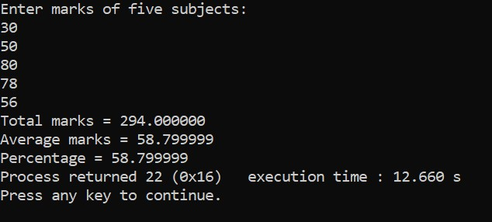

2. WAP that calculates the Simple Interest and Compound Interest

#include<stdio.h>
#include<conio.h>
#include<math.h>
void main()
{
float p, t, r, si, ci;
printf("Enter principal amount (p): ");
scanf("%f", &p);
printf("Enter time in year (t): ");
scanf("%f", &t);
printf("Enter rate in percent (r): ");
scanf("%f", &r);
si = (p * t * r)/100.0;
ci = p * (pow(1+r/100, t) - 1);
printf("Simple Interest = %f\n", si);
printf("Compound Interest = %f", ci);
getch();

}

Output:

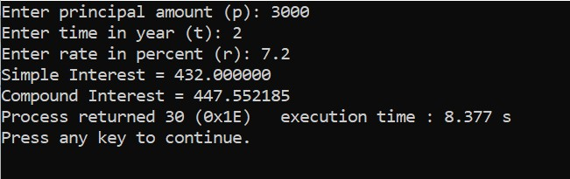

3. WAP to calculate the area and circumference of a circle.

#include<stdio.h>
#include<conio.h>
void main()
{
float radius, area, cf;
printf("Enter Radius of Circle\n");
scanf("%f",&radius);
area=3.14*radius*radius;
printf("The area of Circle is %f",area);
cf=2*3.14*radius;
printf("\nThe Circumference of Circle is %f",cf);
getch();
}

Output:

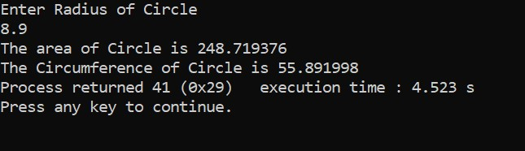

4. WAP that accepts the temperature in Centigrade and converts into Fahrenheit using the formula C/5=(F-32)/9.

#include<stdio.h>
#include<conio.h>
void main()
{
float fahrenheit, centigrade;
printf("enter temperature in Centigrade ");
scanf("%f",&centigrade);
fahrenheit =((centigrade*9)/5)+32;
printf("\n Temperature in fahrenheit is: %f",fahrenheit);
getch();

}

Output:

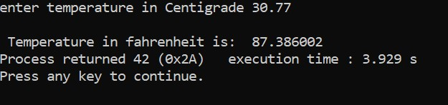

5. WAP that swaps values of two variables using a third variable
#include<stdio.h>
#include<conio.h>
void main()
{
int a,b,temp;
printf("Enter a=");
scanf("%d",&a);
printf("Enter b=");
scanf("%d",&b);
printf("Befter swapping The values are %d and %d\n",a,b);

temp=a;
a=b;
b=temp;

printf("Befter swapping The values are %d and %d",a,b);
getch();

}

Output:

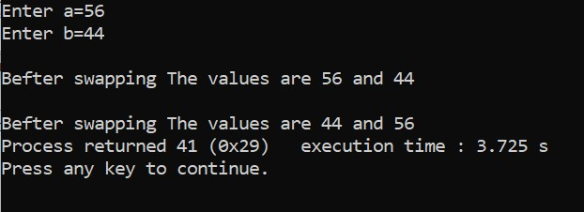
LAB 2

6. WAP that checks whether the two numbers entered by the user are equal or not.
#include<stdio.h>
#include<conio.h>

void main()
{
int a,b;
printf("Enter a=");
scanf("%d",&a);
printf("Enter b=");
scanf("%d",&b);

if(a==b)
{
printf("\na and b are equal.");
}
else
{
printf("\na and b are not equal.");
}
getch();
}

Output:

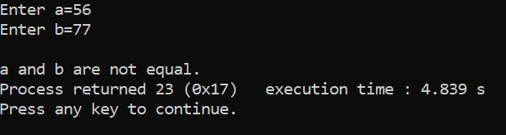

7. WAP to find the greatest of three numbers.
#include<stdio.h>
#include<conio.h>
void main()
{
int a,b,c;
printf("Enter a=");
scanf("%d",&a);
printf("Enter b=");
scanf("%d",&b);
printf("Enter c=");
scanf("%d",&c);
if(a>b)
{
if(a>c)
{
printf("\na is greatest.");
}
else
{
printf("\nc is greatest.");
}
}
else
{
if(b>c)
{
printf("\nb is greatest.");
}
else
{
printf("\nc is greatest.");
}
}
getch();
}

Output:

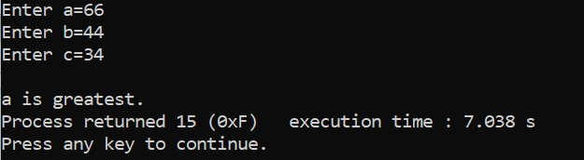
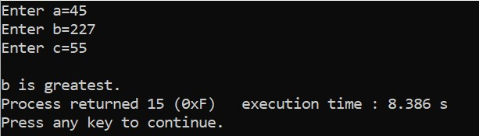
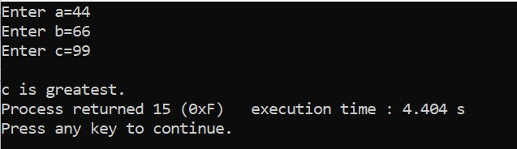

8. WAP that finds whether a given number is even or odd.

#include<stdio.h>
#include<conio.h>
void main()
{
int n;
printf("Enter a number=");
scanf("%d",&n);
if(n%2==0)
{
printf("\n is even number.");
}
else
{
printf("\n is odd number.");
}
getch();
}

Output:

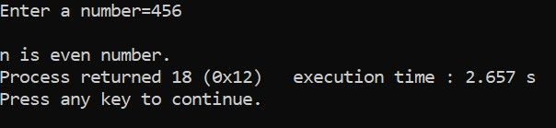

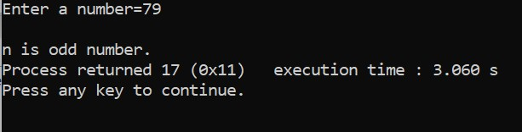

9. WAP that tells whether a given year is a leap year or not.

#include<stdio.h>
#include<conio.h>
void main()
{
int year;
printf("Enter a number=");
scanf("%d",&year);
if((year%4==0 && year%100!=0)||(year%400==0))
{
printf("\nYear is leap year.");
}
else
{
printf("\nYear is not leap year.");
}
getch();
}

Output:

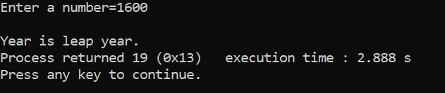

10. WAP that accepts the marks of 5 subjects and finds the sum and percentage marks obtained by the student.
#include<stdio.h>
#include<conio.h>
void main()
{
int hindi, english, science,math,computer,sum ;
float per;
printf("Enter Your five subject marks ");
scanf("%d%d %d %d %d ",&hindi, &English, &science, &math, &computer);
sum=hindi+english+science+math+computer;
printf("Sum of marks=%d",sum);
per=(float)sum/5;
printf("\nPercentage of marks=%f",per);
if(per>=90&&per<=100)
{
printf("\nGrade A");
}
else if(per>=80&&per<90)
{
printf("\nGrade B");
}
else if(per>=60&&per<80)
{
printf("\nGrade C");
}
else if(per<60)
{
printf("\nGrade D");
}
getch();
}

Output:

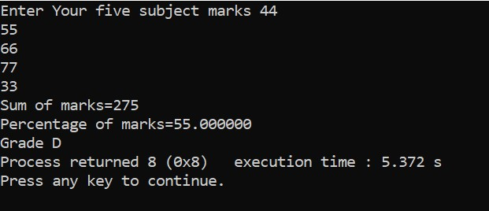
LAB 3

11. Write a program that takes two operands and one operator from the user and performs the operation and prints the result by using the Switch statement.

#include <stdio.h>
#include<conio.h>
void main ()
{
int num1, num2;
char operator;
int result;
printf ("Input any two numbers ");
scanf ("%d%d", &num1,&num2);
printf ("Enter any operator(+,-,*,/) as a choice ");
scanf (" %c", &operator);
switch (operator)
{
case '+':
printf("The Result is %d",num1+num2);
break;
case '-':
printf("The Result is %d",num1-num2);
break;
case '*':
printf("The Result is %d",num1*num2);
break;
case '/':
printf("The Result is %f",(float)num1/num2);
break;
default:
printf ("Error! Wrong Operator.");
}
getch();
}

Output:

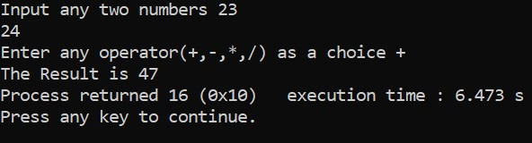
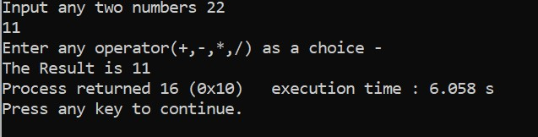

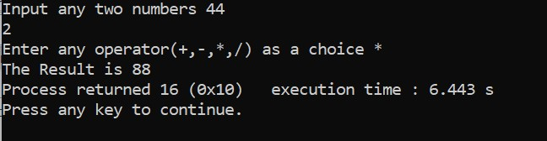

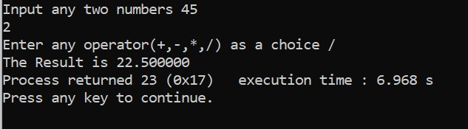

LAB 4
12. Write a program to print the sum of all numbers up to a given number.

#include<stdio.h>
#include<conio.h>
void main()
{
int i=1 , n, sum=0;
printf(“enter the value of n”);
scanf(“%d”, &n);
while(i<=n)
{
sum=sum+i;
i++;
}
printf(" The sum of n natural numbers are %d",sum);
getch();
}

Output:

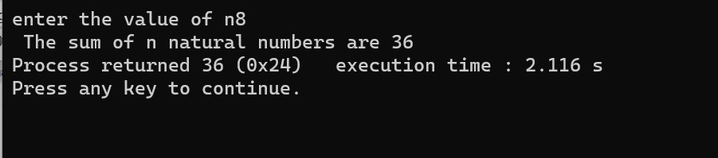

13. Write a program to find the factorial of a given number.

#include<stdio.h>
#include<conio.h>
void main()
{
int i, fact=1,number;
printf("Enter a number: ");
scanf("%d", &number);
if(number<0)
{
printf(“factorial is not possible”);
}
else
{
for(i=1; i<=number; i++)
{
fact=fact*i;
}
printf(“factorial of %d is: %d", number, fact);
}
getch();

}

Output:

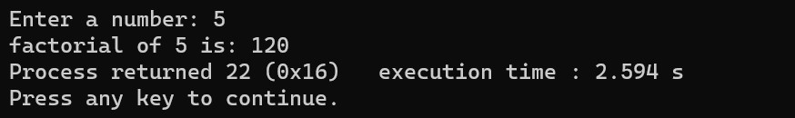

14. Write a program to print the sum of even and odd numbers from 1 to N numbers.

#include<stdio.h>
#include<conio.h>
void main()
{
int n, sumeven=0,sumodd=0,i;
printf("Enter the value of n");
scanf("%d",&n);
for(i=1;i<=n;i++)
{
if(i%2==0)
{
sumeven=sumeven+i;
}
else
{
sumodd=sumodd+i;
}
}
printf("sum of even elements are %d\n",sumeven);
printf("sum of odd elements are %d",sumodd);
getch();
}

Output:

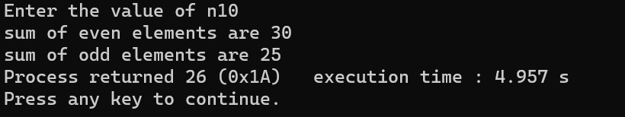

15. Write a program to print the Fibonacci series.

#include<stdio.h>
#include<conio.h>
void main()
{
int n, first = 0, second = 1, next, c;
printf("Enter the number of terms");
scanf("%d", &n);
printf("First %d terms of Fibonacci series are:\n", n);
for (c = 0; c < n; c++)
{
if (c <= 1)
next = c;
else
{
next = first + second;
first = second;
second = next;
}
printf("%d ", next);
}
getch();
}

Output:

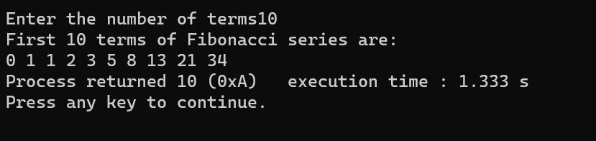

16. Write a program to check whether the entered number is prime or not.
#include <stdio.h>
#include <conio.h>
main()
{
int n, i, count=0;
printf("Enter any number n:");
scanf("%d", &n);
for (i = 1; i <= n; i++)
{
if (n%i==0)
{
count++;
}
}
if (count == 2)
{
printf("n is a Prime number");
}
else
{
printf("n is not a Prime number");
}
getch();
}

Output:

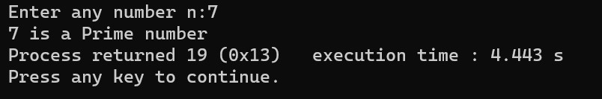

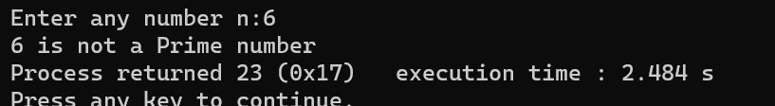

LAB 5
17. Write a program to find the sum of digits of the entered number.

#include<stdio.h>
#include<conio.h>
void main()
{
int n, t, sum = 0, remainder;
printf("Enter an integer\n");
scanf("%d", &n);
t = n;
while(t != 0)
{
remainder = t % 10;
sum = sum + remainder;
t = t / 10;
}
printf("Sum of digits of %d is %d\n", n, sum);
getch();
}

Output:

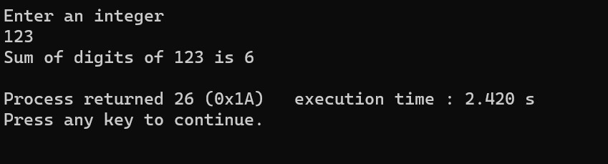

18. Write a program to find the reverse of a number.

#include<stdio.h>
#include<conio.h>
void main()
{
int n,rem,t,rev=0;
printf("Enter a number to reverse\n");
scanf("%d", &n);
t=n;
while(t!= 0)
{
rem = t%10;
rev = rev*10+rem;
t = t/10;
}
printf("Reverse of %d is %d\n",n,rev);
getch();
}

Output:

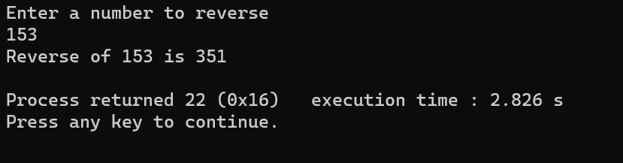

19. Write a program to print Armstrong numbers from 100 to 999.

#include<stdio.h>
#include<conio.h>
void main()
{
int n, t,sum, remainder;
printf("The armstrong numbers between 100 and 999 are:\n");
for(n=100;n<=999;n++)
{
t = n;
sum=0;
while(t != 0)
{
remainder = t % 10;
sum = sum + remainder* remainder* remainder;
t = t / 10;
}
if(n==sum)
{
printf(“%d”,n);
}
}
getch();
}

Output:

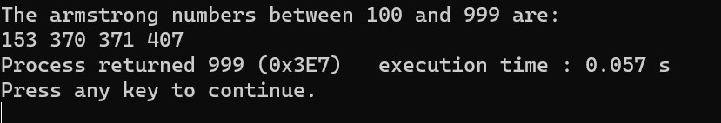

20. Write a program to convert the binary number into a decimal number and vice versa.

- Binary to Decimal

#include<stdio.h>
#include<math.h>
#include<conio.h>
void main()
{
int n, dec=0, i=0,rem,t;
printf("Enter a binary number: ");
scanf("%d",&n);
t=n;
while(t!=0)
{
rem=t%10;
dec=dec+rem*pow(2,i);
t=t/10;
i++;
}
printf("%d in binary = %d in decimal",n,dec);
getch();
}

Output:

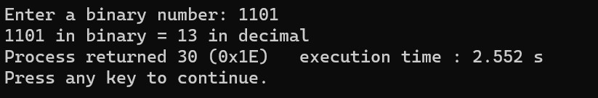

- Decimal To binary

#include<stdio.h>
#include<math.h>
#include<conio.h>
void main()
{
int n, bin=0, i=0,rem,t;
printf("Enter a decimal number: ");
scanf("%d",&n);
t=n;
while (t!=0)
{
rem=t%2;
bin=bin+rem*pow(10, i);
t=t/2;
i++;
}
printf("%d in decimal = %d in binary",n,bin);
getch();
}

